iMovie Podcasting

Add a photo:
- Save a photo from Google or CreativeCommons on to your desktop.
- Drag the picture from the desktop to Project Browser.

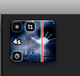

Fig. 1: The sun is the color settings on the image. The box is the crop and Ken Burns effect controls. The clock is for changing the duration of the image (which is 4 seconds now). The red line shows the point in the movie that is displayed in the viewer.

Add video:
- Click on the video camera in iMovie.

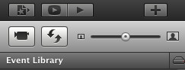

- This will open a new window (Import From: Built-in iSight):

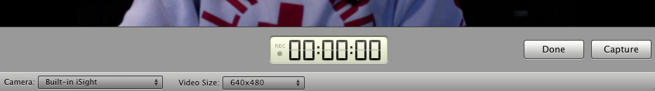

Fig. 3: Make sure that the camera says built in isight. You can choose the video size. The clock tells you when you are recording, where you are at, and how long the clip is.

3. Click on the apple in the top left hand corner. Click on System Preferences. Click on Sound.

4. Change the input to USB microphone. Make sure that the input volume lights up when you talk. Make sure the output is high enough that you can hear it back.

- Go back to the iMovie camera window. Click Capture to record and Done to end the clip.

Edit Movie:
- In the Event Browser, highlight the part of the video you want to put in your movie. It will show on your movie clip in yellow. Drag to Project Browser.
- In the Project Browser, highlight and delete any parts of the video you don’t want.

Add Voiceover:
- Click on the microphone icon (Voiceover).
- Click on the clip/picture you want to record over. The program will give you a three second count down. When you are done. Click out of the sound window.
- To cut off the end of the voiceover, click on the purple voiceover clip that is now in your Project Browser.
- It will turn to a yellow outline and you can cut out what you want, just like the video editing.

Add a Title:
- Click on the “T” icon for the title menu

- Drag the type of title you want on top of the clip you want to add it to.
- In the Movie Viewer, type in the title. What you see in the viewer, is how it will look. Then click done.

Export to QuickTime (.mov):
- Click on Share, then Export using Quicktime.
- Name the movie and then click save.
- iMovie will then convert the movie into a .mov that you can save anywhere and view in Quicktime or upload to a blog or Youtube.

Upload to YouTube:
- Go to youtube.com.
- Sign in or create account.
- Click on your username and then My Videos.
- Click on New in the top left corner, and then Video Upload.
- Click on Upload Video.
- In the pop-up window, select the video you want to upload and then click Upload.
- You can then name your video, write a description, add a category and search terms, and set privacy settings.
- When you are done, hit Save Changes.
- If you click back under your username into MyVideos, you new upload will appear.
- Click on the video you want to view or embed.

Embed in Blog:
- Keep the youtube screen open.
- Sign in to your blog.
- Make a new post. You can add multimedia and copy and past the embed code from youtube (top right corner of screen) into your blog. OR most blogging sites let you click an add YouTube video button and then copy and paste the URL in.
- Click post or update in your blog to publish the video to your page.

